Homework 3

1.

2.

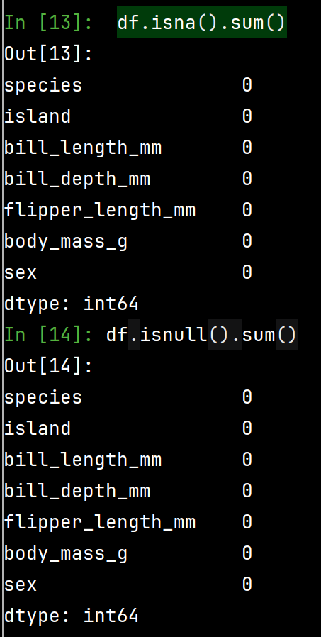

3.

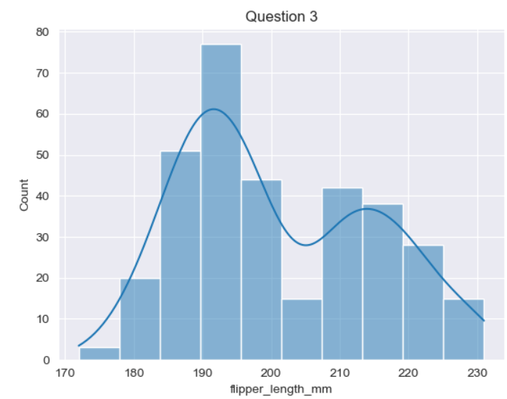

Observation: There are two peaks in the graph. Most species have the flipper length around 190mm, and second most is around 215mm.

4.

Observation:

5.

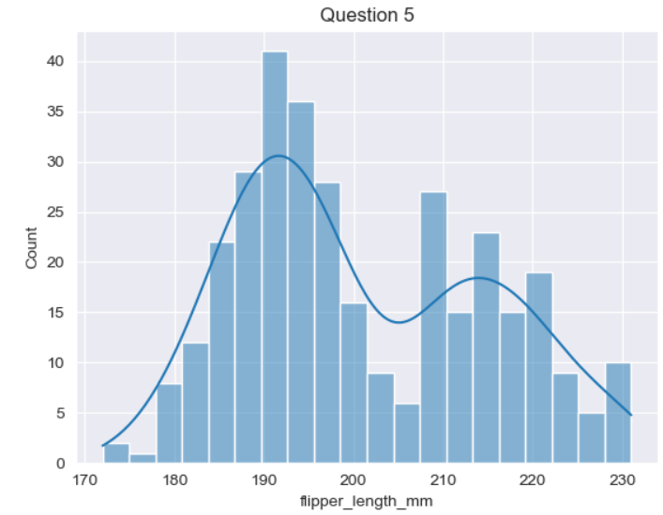

6.

7.

8.

9.

10.

11.

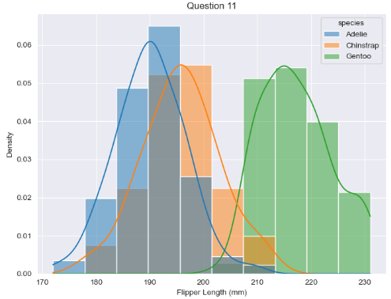

12.

13.

Gentoo penguins have the highest probability around 210-220 mm flipper length. Adelie penguins are most probable around 185-195 mm. Chinstrap penguins are most probable around 190-200 mm.

14.

15.

16.

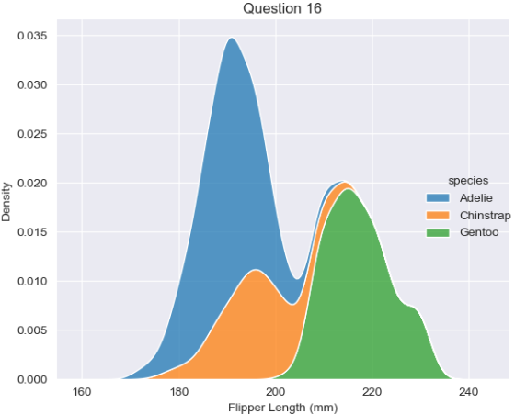

17.

18.

19.

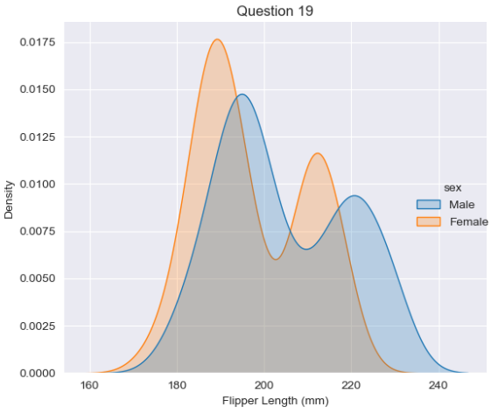

20.

21.

22.

23.

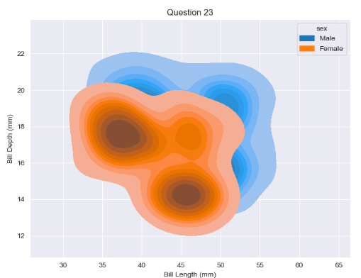

24.

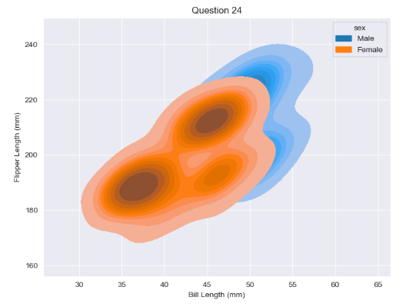

25.

26.

27.

28.

29.

